
YEAR 12 CHEMISTRY – 3BCHE

TEST 4: Redox and Electrochemistry

Recommended time: 1 hour

/45

Name: _____________________________________________________

Teacher: _____________________________________________________

This test is in two parts.

Part 1: Multiple choice style consisting of ten (10) questions.
Each question is worth 1 mark.
Write your answers in the table provided below.
Attempt ALL Questions

Part 2: Short and/or Extended Answer questions
Write all answers in the spaces provided.
The marks allocated to each question are shown next to each question.

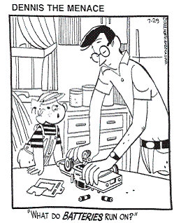

Multiple Choice Answer Table

Write your answer to the Multiple Choice Section in the appropriate box. This part is worth 10 marks.

1 | 2 | 3 | 4 | 5 | 6 | 7 | 8 | 9 | 10

1. In which of the following species is the oxidation number of manganese equal to (+2)?

A K2MnO4
B Mn2O3
C NaMnO4
D Mn(HCO₃)₂
2. For the following unbalanced chemical equation below:

...Cu(s) + ...NO₃⁻ (aq) + ...H⁺(aq) → ....Cu²⁺(aq) + ...NO(g) + ...H2O(1)

Which of the following gives the correct coefficients, reading from left to right in the balanced equation?

A 2, 3, 2, 2, 3 and 1

B 3, 2, 8, 3, 2 and 4

C 2, 2, 4, 2, 1 and 2

D 3, 1, 4, 3, 1 and 2

3. Which of the following would be most likely to react with a 1.0 molL⁻¹ solution of KI to produce a brown solution but show no visible change with a 1.0 molL⁻¹ NaBr solution in standard conditions?

A A 1.0 molL⁻¹ solution of FeCl₂

B A 1.0 molL⁻¹ solution of dilute hydrochloric acid

C A 1.0 molL⁻¹ solution of FeCl₃

D A 1.0 molL⁻¹ solution of Cl₂ (or chlorine water)

4. A lemon battery can be made from a simple set up using a copper strip, an iron strip and a lemon (see diagram)
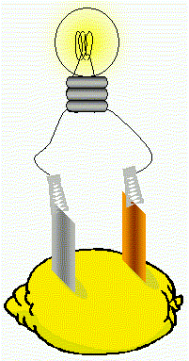
The negative electrode in this cell is the

A iron strip
B copper strip
C lemon juice
D O₂(g) and H₂O
5. Which of the following slows down the corrosion of a small strip of iron?

A Attaching a length of zinc metal to the iron

B Wrapping a length of freshly cleaned nickel metal to the iron

C Partly immerse the iron metal in a solution of boiled hydrochloric acid solution

D Storing the iron metal under sea water

6. An electrochemical cell is constructed from the following half cells, at 25°C.

Half cell | Electrode | Electrolyte
1 | Silver metal | 1.0 molL⁻¹ solution of AgNO₃
2 | Copper metal | 1.0 molL⁻¹ solution of Cu(NO₃)₂

Which one of the following is likely to occur?

A The copper electrode will increase in mass.

B Bubbles of gas will form at the copper electrode.

C The concentration of silver ions in solution will increase.

D The blue colour of the copper (II) nitrate solution will become more intense.

7. 4.00 g of impure iron was dissolved in excess dilute sulfuric acid, H₂SO₄ and the solution made up to 500 mL. 25.0 mL of this solution required 19.8 mL of 0.0305 mol L-1 potassium permanganate solution for complete oxidation. The equation is as follows:

MnO₄⁻(aq) + 8H⁺(aq) + 5Fe²⁺(aq) → Mn²⁺(aq) + 5Fe³⁺(aq) + 4H₂O(aq)

The percentage purity of the iron sample is

A (19.8 x 0.0305) x 5 x 500 x 55.85 x 100 or 84.3%
1000 25.0 4

B (19.8 x 0.0305) x 1 x 500 x 55.85 x 100 or 3.37%
1000 5 25.0 4

C (19.8 x 0.0305) x 5 x 500 x 55.85 x 4 or 0.13%
1000 25.0 100

D (19.8 x 0.0305) x 5 x 25.0 x 55.85 x 100 or 0.21%
1000 500 4

8. The oxidation numbers of nitrogen in HNO₃, NO and NH₂OH are
A. 1, +2 and +1 respectively
B. –5, +2 and –1 respectively.
C. +5, +2 and –1 respectively.
D. +5, +4 and +1 respective

9. Which of the following metals, when placed in a solution of nickel (II) sulfate, would cause the solution to fade from green to colourless?

- Lead

- Zinc

- Chromium

- Iron

10. Which of the following equations does not represent a redox reaction?

- Mg(s)+ 2 HC(aq) MgC₂(aq) + H₂(g)

- Mg(OH)₂(s) + 2 CH₃COOH(aq) Mg(CH₃COO)₂(aq) + 2 H₂O()

- Sn²⁺(aq) + Zn(s) Sn(s) + Zn²⁺(aq)

- CH₄(g) + 2 O₂(g) CO₂(g) + 2 H₂O(g)

End of Multiple choice section: GO ON TO SHORT ANSWER QUESTIONS

PART 2 : SHORT ANSWER: ANSWER ALL THE QUESTIONS IN THE SPACES PROVIDED BELOW (35 marks )

Answer each of the following questions in the space provided. Give ALL numerical answers to three (3) significant figures. Marks will be deducted for the incorrect use of significant figures.
Q1. Predict whether a reaction will occur when an iron nail is placed in an aqueous solution of tin (II) chloride. Assume standard conditions. If yes, write the equation for the reaction (use ionic equations where appropriate).
If no, give reason.

…………………………………………………………………………………………………………………………………….

…………………………………………………………………………………………………………………….. (2 marks)

Q2. Consider the electrochemical below: (7 marks total)

2(a) Write the half-equation for the reaction which occurs at the cathode. (1 mark)
……………………………………………………………………………………………………………………

2(b) Write the equation for the overall redox equation in the cell. (1 mark)

……………………………………………………………………………………………………………………..

2(c) Calculate the EMF (voltage) of the cell at standard conditions. (1 mark)

……………………………………………………………………………………………………………………….

Q2/…. cont’d
2 (d) Both the anode and cathode have a mass of 5.00 g before they are connected in the cell.
The electrodes are connected for 10 minutes and one of the electrodes was found to have a
mass of 7.50 g when reweighed. What is the mass of the other electrode after this time? (4 marks)

Q3. An Internet site reporting the latest developments in fuel cell technology describes a cell that uses a solid ceramic material as the electrolyte and hydrogen gas and oxygen gas as the reactants.

Key features of this cell are:

- water is the only product from the cell reaction

- the ceramic material allows the movement of oxide ions (O²⁻) from the cathode to anode.

- the reaction at the anode is H₂ (g) + O²⁻ (in ceramic) → H2O(l) + 2è

- operation at very high temperatures of over 1000°C means that precious metal catalysts are not required.
A representation of the cell providing electricity for an appliance is shown in the diagram below.

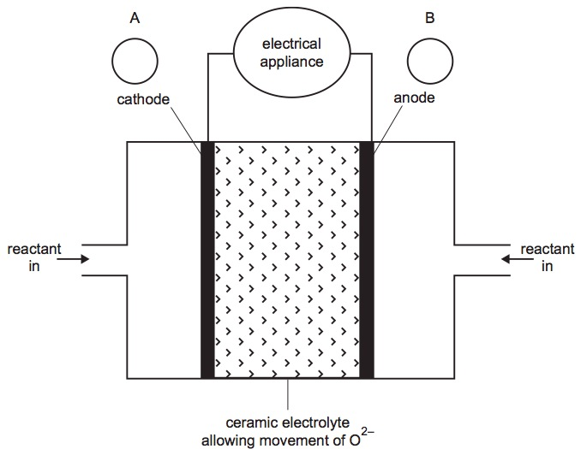

Q3/… cont’d

3 (a ) State ONE (1) feature that distinguishes a fuel cell from an electrochemical cell such as a dry cell or lead-acid battery? (1 mark)
………………………………………………………………………………………………………………………………..
3 (b) On the diagram of the fuel cell
(i) in circles A and B, indicate the polarity of the cathode and anode.

(ii) show, by using an arrow, the direction of electron flow in the external circuit. (2 marks)

3 (c) Write an equation for each of the following reactions. You are not required to show states in these two
equations.
(2 marks)
The reaction at the cathode

The overall cell reaction

Q4. When an acidified solution of potassium permanganate (KMnO₄) is added to a solution of potassium chlorate (KClO₃), the main products formed are manganese (IV) dioxide (MnO₂) and potassium perchlorate (KClO₄).

Write a balanced equation for this reaction by first balancing the half equations for both the oxidation and reduction processes. (6 marks total)

- oxidation process:

_____________________________________________________________________________
(2 marks)
- reduction process:

_____________________________________________________________________________

(2 marks)
- fully balanced redox equation:

_____________________________________________________________________________
(2 marks)

Q5. Hairdressers use hydrogen peroxide to bleach hair. An analyst uses a pipette to transfer 20.00 mL of commercial hairdressers’ hydrogen peroxide to a 250.0mL volumetric flask, and she makes the volume up to the mark with distilled water. She places 20.00mL portions of this solution in a titration flask, adds 5.00mL of 2.00 mol L⁻¹ sulfuric acid, and titrates the mixture with 0.02056 mol L ⁻¹ potassium dichromate. She records the following titration figures:

Final reading (ml) | 29.5 | 29.53 | 29.35 | 28.74 | 28.62
Initial reading (ml) | 0.11 | 1.55 | 0.41 | 0.81 | 0.66
Titre (ml)

5 (a) Calculate the appropriate value for the volume of potassium dichromate solution required for titration (2 marks)
…………………………………………………………………………………………………………………………….

5 (b) What would be the colour change be at the end point from _________ to _________ (1 mark)

5 (c) Calculate the concentration, in mol L⁻¹, and g L⁻¹ of the original commercial hairdressers’ hydrogen peroxide solution. (6 marks)

Q6. A group of students decided to conduct a mini-research project on methods of preventing corrosion of iron structures in a salt water environment. A number of iron plates, numbered 1 to 5, were placed in sea water as shown below. (6 marks total)
1.  untreated iron | 2.  iron partly covered with tin |  | 3.  iron partly covered with zinc
Iron  nail  5V  - +  4.  iron attached to  negative terminal of battery |  | Iron  nail  5V  + -  5.  iron attached to  positive terminal of battery

6 (a) Which two plates showed the least degree of corrosion? Give reasons (3 marks)
...........................................................................................................................................................

………………………………………………………………………………………………………………….

………………………………………………………………………………………………………………….

............................................................................................................................................................

………………………………………………………………………………………………………………….

6 (b) Which two plates showed the greatest degree of corrosion? Give reasons. (3 marks)
............................................................................................................................................................
...........................................................................................................................................................

………………………………………………………………………………………………………………….

………………………………………………………………………………………………………………….

............................................................................................................................................................

END OF TEST 4: REDOX and ELECTROCHEMISTRY 2014

